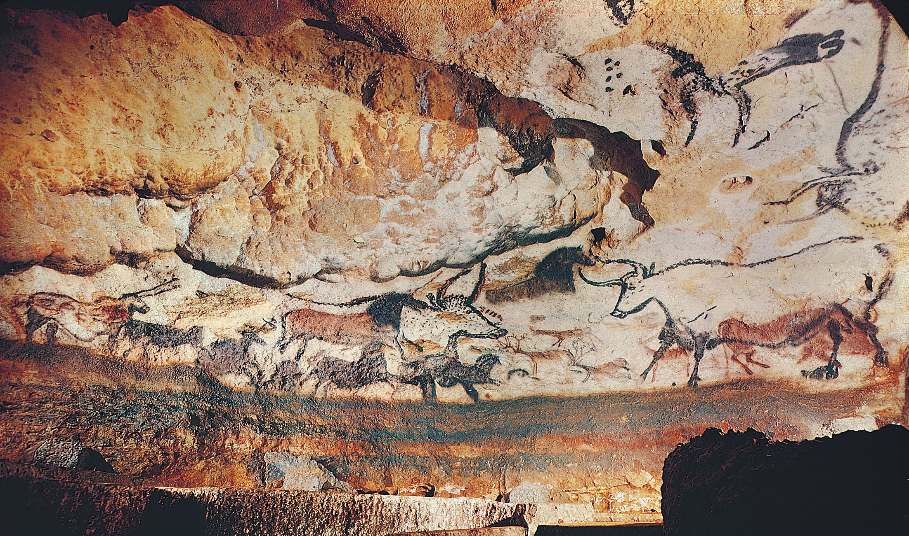
Image #2 Great Hall of the Bulls
Unit 1 | - Global Prehistory - 30,000 - 500 BCE
IDENTIFIERS  Title/designation  Artist/Culture  Date of creation | - Great Hall of Bulls  - Lascaux, France  - Paleolithic, Europe  - 15,000 - 13,000 bce
FORM  Use of design elements/principles: color, shape, value, texture, line, space; balance, contrast, emphasis, movement, etc | - 650 paintings  - Mostly common animals are cows, bulls, horses and deer  - Bodies seen in profile, frontal or diagonal views of horns, eyes and hooves; some appear pregnant - Twisted perspective  - Various animals, human and abstract forms  - No backgrounds or vegetation  - Mural painting - deep in a cave  - Figures show great movement as in a hunt  - Limited colors, composite view or twisted perspective/silhouettes/outlines
MATERIALS & TECHNIQUES  Art making processes and use of material | - Natural products were used to make paint: charcoal, iron ore, plants  - Walls were scraped to an even surface  - Paint colors were bound were bound with animal fat  - Lamps lighted the interior of caves
CONTENT  Subject matter, iconography, depiction, symbolism, the story | - Animals placed deep inside cave - some hundreds of feet from the entrance  - Evidence still visible of scaffolding erected to get to higher areas of the caves  - Negative hand prints, are these signatures?  - Caves were not dwellings, as prehistoric people let migratory lives following herds of animals; some evidence exists that people did seek shelter at the mouth of caves
CONTEXT  place/site/audience: why was the artists’s intent significant? | - Discovered in 1940; open to the public after World War II  - Closed to the public in 1963 because of damage from human contact  - New replica opened adjacent
INTENDED FUNCTION & PURPOSE  Why was it made?  PATRON  Who was it made for? | - Used to ensure a successful hunt  - Ancestral animal worship  - Shamanism: a religion based on the idea that the forces of nature can be contacted by intermediaries, called Shamans; who go into a trancelike state to reach another state of consciousness
INNOVATION/CHANGE
CONVENTION/  TRADITION | - Hunter-gatherer lifestyle
THEME(S) | - Animal Worship  - Shamanism
COMPARE TO ANOTHER WORK(S) | - Tomb of the Triclinium  - Last Supper - da Vinci  - Darkytown Rebellion
ADDITIONAL NOTES/DRAWINGS

